- Questionary Parts of A,B,C,D and E are followed below.

A - Cat Food Sales by State:

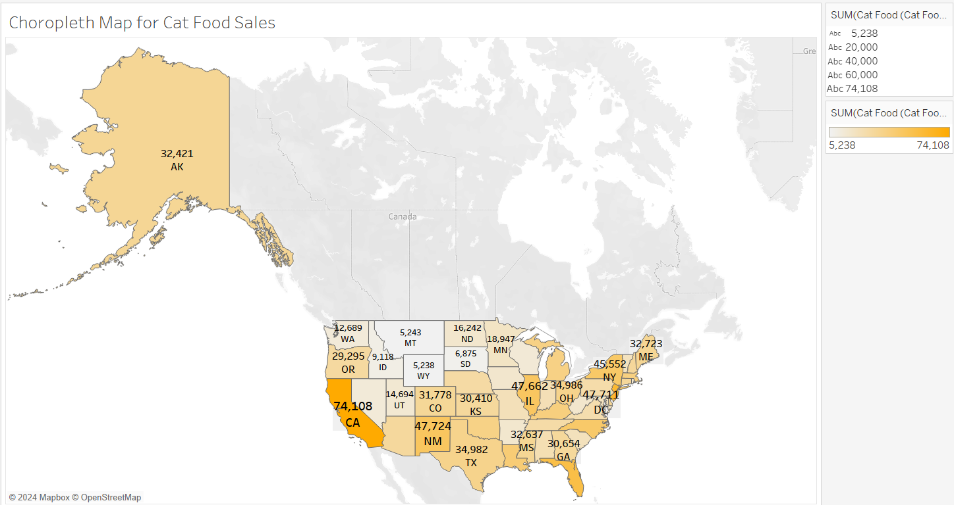

The summary given summarizes the main conclusions drawn from a graph showing the total quantity of cat food sold in each state.

The chart displays the total amount of cat food sold per state. Florida (FL), New Jersey (NJ), and California (74,108) had the most cat food sales, according to the data. In places such as Wyoming (WY), Montana (MT), and South Dakota (SD), cat food sales are somewhat lower. Though it might be challenging to pinpoint specific trends without a visual help, geographic patterns may become apparent. The map displays the states with the highest or lowest sales of cat food.

B - Dog Food Sales by State:

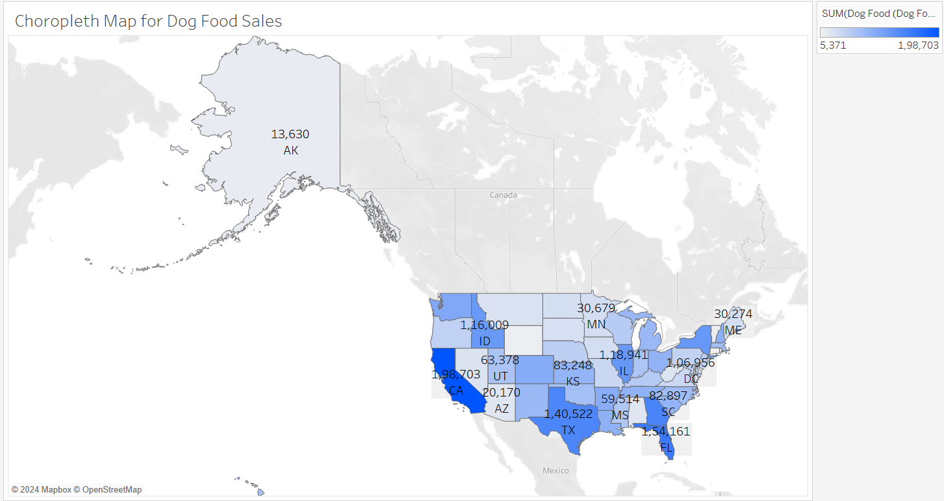

The explanation given focuses on the most important findings from a map that shows the total quantity of dog food bought in each state.

The dog food sales map, like the cat food sales map, displays the total amount of dog food purchased per state. The geographical regions of California, Florida (FL), and Georgia (GA) have the greatest dog food sales. Dog food sales are somewhat lower in the states of Vermont (VT), Wyoming (WY), and Connecticut (CT). Once more, the visual map facilitates a deeper comprehension of regional variations and trends.

C – Exploring the relationship Between Total Cat food Sales and total dog food sales across state:

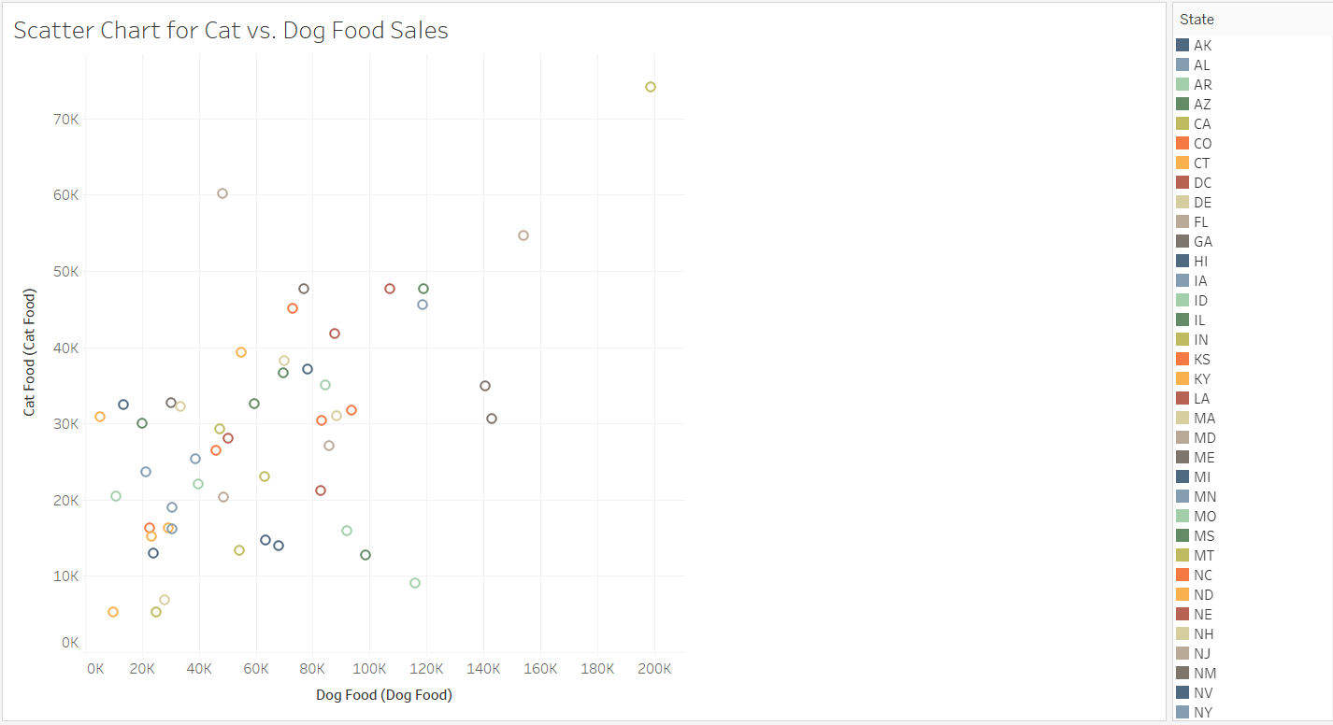

In the above Scatter Chart for Cat vs. Dog Food Sales, we can see that California has the greatest food sales, followed by New Jersey in second place. The following states have comparable sales of Cat vs. Dog Food: New Mexico, Washington, DC, Illinois.

The association between all dog and cat food sales in each state is shown in the scatter plot. If states that sell more cat food also tend to sell more dog food, then there appears to be a general positive correlation. Though there is significant variation evident in the data points, a closer look could reveal certain patterns or anomalies.

D – Analyzing Total Cat and Dogs Food sales in Wyoming Relative to other States:

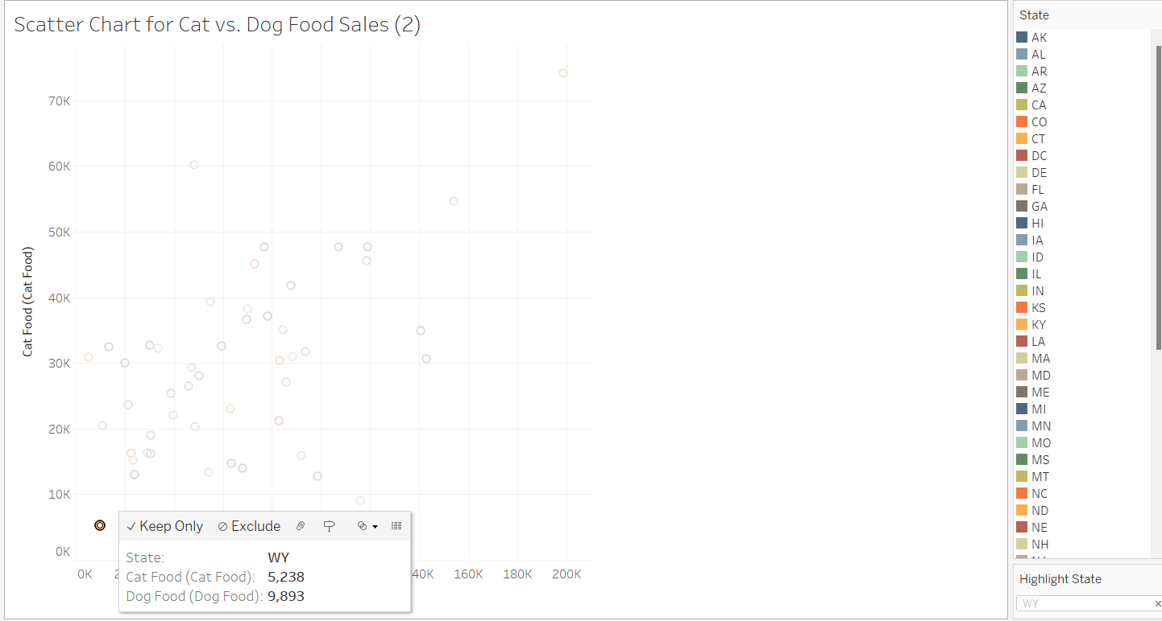

It is clear by emphasizing Wyoming (WY) in the scatter chart that, in comparison to other states, Wyoming has comparatively fewer sales of dog food (9,893) and cat food (5,238). This data offers a brief visual comparison that illustrates Wyoming's standing with regard to sales of dog and cat food.

E - Inherent Weaknesses and Improvements:
- The inability of absolute sales figures to accurately indicate market dominance is one of its drawbacks. By normalizing the data according to population or location, more meaningful conclusions may be drawn.

- A bubble chart was made in Tableau using the "total sales" metric as the bubble size, which represents the size of the whole market, in order to facilitate the study of Pet Fare cat and dog food sales. By graphically integrating the volume of sales of both dog and cat food, this method resolves inequalities in state markets. X-axis, Y-axis, and bubble size may all be displayed concurrently in a bubble chart, which gives a more thorough perspective and makes state-to-state comparisons simpler than with a choropleth map.

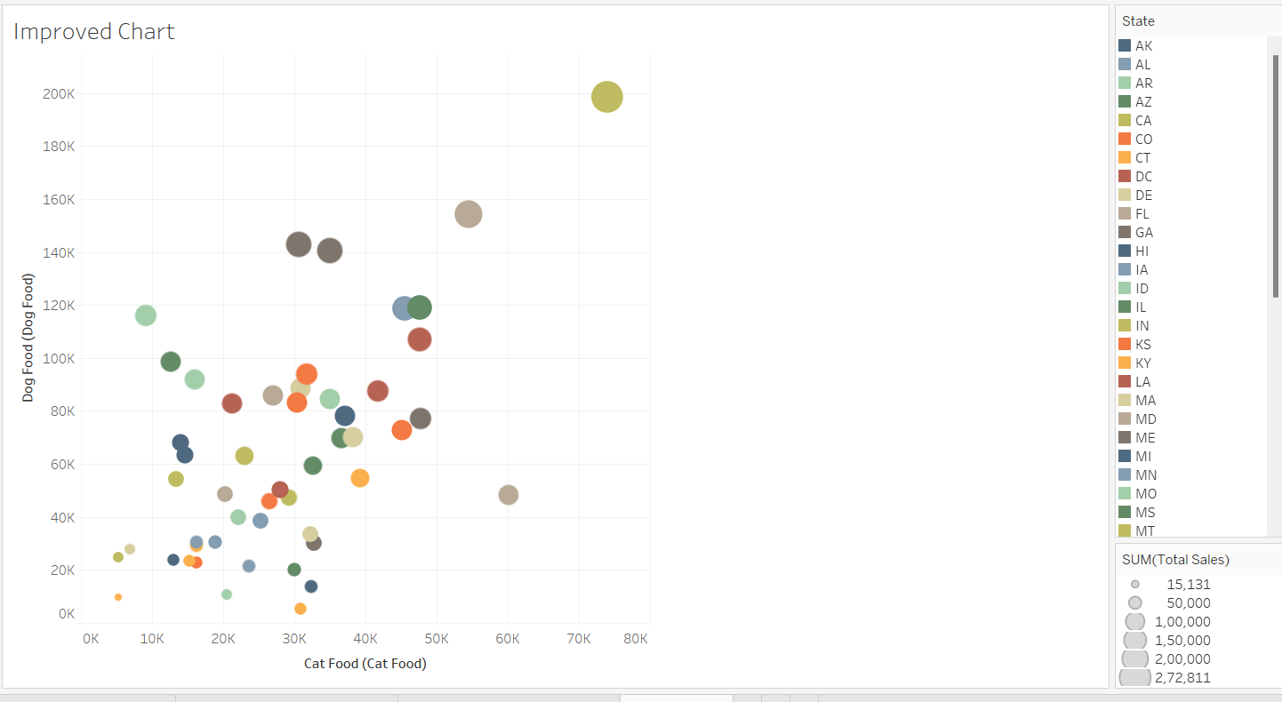

- a.) Enhancing Table comprehensibility.

- To properly name the table, use headings and subleaders.
- Use millions or billions to format numbers to make them simpler to read.
- Use the GDP model to understand the growth of GDP in individual years.
- Use the colour fount Orange, Accent 6, Lighter 60% for better understanding.
- It will be helpful for better understanding of GDP in the table format compared to graph.

b.) Excel file of GDP years.
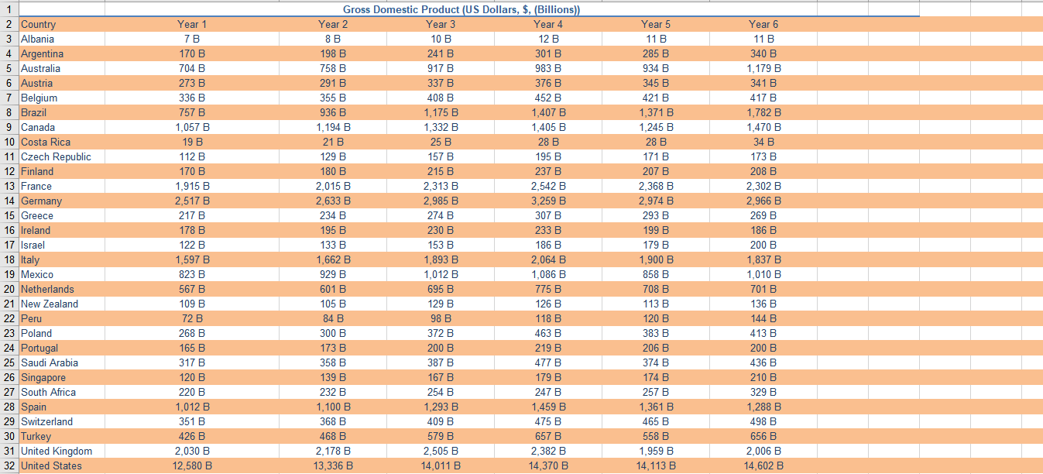

- Improving Trend identification in Sackenheim compressors cost Analysis.

The Gestalt "Principle of Continuity" is a useful concept for seeing patterns in the data. According to this theory, objects organized in a line or curve are seen as having more relationships than those that are not arranged in this way. The audience can better understand the overall trend in the data when a line chart is presented with a continuous and smooth line.

Enhanced Diagram

